**Coding Plagiarism:**  Copying or reproducing code that is not yours, without permission from the author, or against the assignment Academic Misconduct Policy. This includes copying code from online examples and fellow students, the use of libraries or frameworks, and the use of code generators.

**Academic Integrity Guidelines:** A per assignment policy that outlines the use of code retrieved from the internet. The policy specifically addresses the use of code documentation, coding examples, libraries, frameworks, and packages.

In your source code, directly above the snippet of code that requires a citation, add a comment including:

* a description of the source code
* the author (name, company, and/or screen name)
* the date it was copied
* a URL to the page the code was copied from

Can programmers use snippets of code from W3Schools for their personal portfolio?  
**Yes, snippets of code is ok.**

* Pan programmers use snippets of code from W3Schools for websites for clients?  
  **Yes, snippets of code is ok.**
* Can students use snippets of code from W3Schools in their projects?  
  Assuming it is permitted by their instructors. Yes, snippets of code is ok.

**Library:** a set of functions that you can call, often organized into classes, that are used alongside the application flow.

**Framework:**provides a structure to build an application within, often the framework replaces the application flow.

//Questions and answers week 1

What is considered plagiarism when writing code in academia?

Hide answer choices

Copying example code from an online resource.

Copying example code from a book or other offline source.

Typing out code from a YouTube video.

Copying code from a fellow student.

**Correct:** All of the above.

Assignment Academic Integrity Guidelines are required on each assignment because:

Hide answer choices

Copying code is allowed in certain circumstances.

The rules for copying code vary with each assignment.

Using prewritten Libraries and/or Frameworks is often required.

**Correct:** All of the above.

What are the academic penalties of plagiarism?

Hide answer choices

Receiving a zero on the assignment.

Meeting with your program coordinator and Associate Dean.

Having the plagiarism instance noted on your academic record.

**Correct:** All of the above.

What is the best way to learn code?

Hide answer choices

Copying code from a YouTube tutorial.

**Incorrect:** Following step-by-step tutorials using online resources.

Struggling for long periods of time writing your own code.

Correct answer:

Watching your professors write code.

When citing code, what details must be included?

Hide answer choices

A description of the source code

The author (name, company, and/or screen name)

The date it was copied

A URL to the page the code was copied from

**Correct:** All of the above.

When copying code, a citation is not required when:

Hide answer choices

Copying example code from a book or other offline source.

**Correct:** Copying code from documentation.

Correct answer

Typing out code from a YouTube video.

Copying code from a fellow student.

Copying example code from an online resource.

A citation is added to your code using:

Hide answer choices

**Correct:** A multiline comment.

Correct answer

A variable.

A footnote.

A single line comment

Using documentation when coding, is the equivalent of using a ___________ when writing an English paper.

Hide answer choices

**Correct:** Dictionary.

Correct answer

Short story.

News article.

Blog.

Which example block of code would not need to be cited if copied?

Hide answer choices

A Python script that loops through a series of files from W3Schools.

A user contributed function that validates an email address from the PHP website.

**Correct:** A sample JavaScript for loop from the Mozilla Developer Network.

An HTML flexbox example from CSS-Tricks.

Before copying code, you must ensure the following:

Hide answer choices

You have permission from the author and/or license.

The assignment permits copying code from this type of source.

The copied code does not directly complete an assignment objective.

You have a clear understanding of the code.

**Correct:** All of the above.

What does BY require in a Creative Common CC-BY license?

Resource: <https://creativecommons.org/licenses/>

Hide answer choices

**Correct:** Attribution: You must give appropriate credit and provide a link to the source of the copied code.

Share Alike: If you build upon the material, you must share your contributions.

Non Commercial: Only noncommercial uses of the code are permitted.

​​Non Derivative: You may not change the code from the original source.

What does AS require in a Creative Common CC-AS license?

Resource: <https://creativecommons.org/licenses/>

Hide answer choices

Attribution: You must give appropriate credit and provide a link to the source of the copied code.

**Correct:** Share Alike: If you build upon the material, you must share your contributions.

Non Commercial: Only noncommercial uses of the code are permitted.

​​Non Derivative: You may not change the code from the original source.

What does NC require in a Creative Common CC-NC license?

Resource: <https://creativecommons.org/licenses/>

Hide answer choices

Attribution: You must give appropriate credit and provide a link to the source of the copied code.

Share Alike: If you build upon the material, you must share your contributions.

**Correct:** Non Commercial: Only noncommercial uses of the code are permitted.

​​Non Derivative: You may not change the code from the original source.

What does ND require in a Creative Common CC-ND license?

Resource: <https://creativecommons.org/licenses/>

Hide answer choices

Attribution: You must give appropriate credit and provide a link to the source of the copied code.

Share Alike: If you build upon the material, you must share your contributions.

Non Commercial: Only noncommercial uses of the code are permitted.

**Correct:** ​​Non Derivative: You may not change the code from the original source.

How would you come to the conclusion that a snippet of code is documentation?

Hide answer choices

The code needs to be adapted to fit your purpose.

The code does not complete an objective.

It is likely only one or two lines of code.

**Correct:** All of the above.

What is the best method to help your fellow students?

Hide answer choices

Send them a copy of your code.

Use screen sharing tools to show them your code.

**Correct:** Review their code and offer verbal suggestions.

Fix their code for them.

Can you use libraries and/or frameworks on an assignment?

Hide answer choices

You can never use libraries and/or frameworks.

Only if the assignment permits the use of libraries and/or frameworks.

**Correct:** Only if the assignment permits the use of libraries and/or frameworks, and the specific library and/or framework is listed.

Review the following Assignment Academic Integrity Guidelines and answer the following questions:

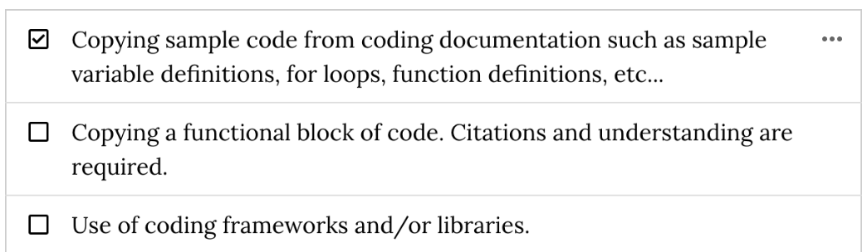

The assignment is to create a well designed HTML/CSS contact form.

Can you use a block of code that provides a sample IMG tag from this source:

<https://www.w3schools.com/html/html_images.asp>

Hide answer choices

**Correct:** Yes.

No.

Review the following Assignment Academic Integrity Guidelines and answer the following questions:

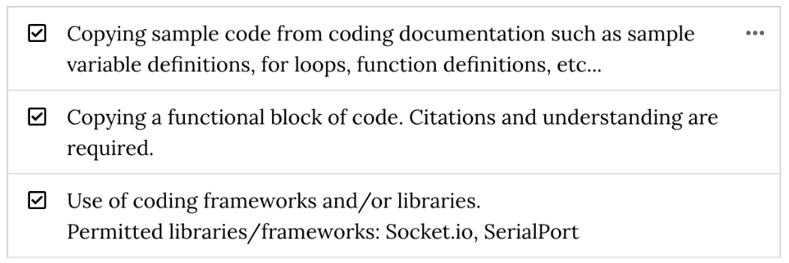

The assignment is to create a JavaScript image slideshow.

Can you use a block of code that provides a sample image slideshow from this source:

<https://www.freecodecamp.org/news/how-to-create-a-slideshow/>

Hide answer choices

**Incorrect:** Yes.

No.

Review the following Assignment Academic Integrity Guidelines and answer the following questions:

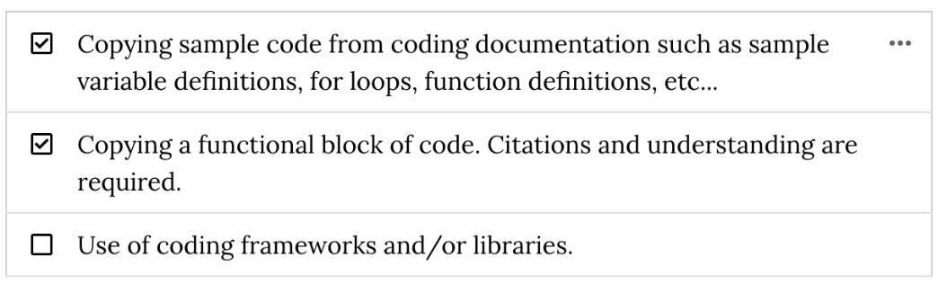

The assignment is to communicate between a webpage and an Arduino.

Can you use React to build the webpage?

<https://reactjs.org/>

Hide answer choices

Yes.

**Correct:** No.